**Cardiovascular study enabled prediction of 10-year risk of future coronary heart disease (CHD) with 5 machine learning, 4 deep learning and ensemble learning approaches examined**

**BIO216 CW2**

**Jiaming Huang**

**Department of Biology**

**Xi’an Jiaotong-Liverpool University**



TABLE OF CONTENTS

**Abstract**  **3**

**1 Introduction 3**

1.1 Coronary heart disease (CHD)

1.2 Previous works

1.3 Our works

**2 Methods**  **5**

2.1 Benchmark dataset

2.2 Risk factors

2.3 Data preprocessing

2.4 Individual models training

2.5 LSTM

2.6 ResNet

2.7 Transformer-Encoder

2.8 Ensemble Learning

2.9 Performance evaluation metrics

2.10 SHAP analysis

**3 Results**  **9**

3.1 Single-model methods evaluation

3.2 Ensemble-model methods evaluation

3.3 Model interpretation

**4 Discussion**  **14**

4.1 Deep learning models reflection

4.2 Ensemble model reflection

4.3 Model Interpretation reflection

**5 Conclusion**   **14**

**6 Code availability 15**

**7 References 15**

**Cardiovascular study enabled prediction of 10-year risk of future coronary heart disease (CHD) with 5 machine learning, 4 deep learning and ensemble learning approaches examined**

**Abstract**

10-year risk of future coronary heart disease (CHD) refers to the probability that a person will develop coronary heart disease within the next ten years. Accurate identification of 10-year risk of future CHD enables healthcare providers to implement preventive strategies, including lifestyle changes, medications, and regular monitoring, thus greatly reducing the risk of CHD. In this study, we firstly examine 5 machine learning models, including Logistic Regression (LR), Naïve Bayes (NB), Random Forest (RF), Support Vector Machine (SVM), and eXtreme Gradient Boosting (XGB) and 4 deep learning models, including Long Short-Term Memory Neural Network (LSTM), Residual Neural Network (ResNet), Convolutional Neural Network (CNN) and 1 dimensional Transformer Encoder (Trans-Encoder). Trained with 6 nominal variables (e.g. male, education and so on) one-hot encoded and 8 continuous variables (e.g. age, BMI and so on) with column-based standardization, the performance of these individual models achieved an AUROC between 0.498 and 0.717. Since ensemble models usually possess multiple advantages, such as improved accuracy, reduced overfitting, and higher robustness, we conducted a comprehensive model selection process and constructed the ensembles of these individual models with different combinations. However, most ensemble models didn’t reach the best performance achieved by individual models and even the best one reached an AUROC of 0.718. Finally, to seek for explanations of this ordinary performance, SHapley Additive exPlanations (SHAP) are applied on those models used for ensemble model construction, providing insight of most important variables for CHD risk prediction.

**Keywords**

Coronary heart disease (CHD); One-hot encoding; Long Short-Term Memory Neural Network (LSTM); Ensemble learning; SHapley Additive exPlanations (SHAP)

**1 Introduction**

**1.1 Coronary heart disease (CHD)**

Coronary Heart Disease (CHD), also known as coronary artery disease, occurs when the coronary arteries that supply blood to the heart muscle become narrowed or blocked. This is primarily caused by the buildup of fatty substances, such as cholesterol, forming plaques on the artery walls, a condition known as atherosclerosis. The accumulation of these plaques restricts blood flow to the heart, leading to insufficient oxygen supply to the heart muscle. This can result in chest pain (angina), heart attacks (myocardial infarctions), and other severe complications. Preventive strategies, including lifestyle changes, medications, and regular monitoring, can greatly reduce the risk of CHD and improve survival rates.

**1.2 Previous works**

There have been many similar works existed previously, which has produced impressive results. Rafiah et al [] developed a system for heart disease prediction using Decision Tree, Naïve Bayes, and Neural Network approaches, showing that Naïve Bayes performs better followed by Neural Networks and Decision Tree. After that, Abdullah and Rajalaxmi [] used Random Forest classifier to predict the future risk of CHD and achieves high accuracy by effectively analyzing multiple risk factors and events such as Angina, Acute Myocardial Infarction (AMI), Percutaneous Coronary Intervention (PCI), and Coronary Artery Bypass Graft surgery (CABG). Moveover, Ayatollahi et al [] compared the predictive power of ANN and SVM models for coronary artery disease. The result indicates that the ANN model demonstrated good predictive power, while the SVM model showed higher accuracy and a better classification performance, especially in terms of AUROC, indicating superior performance in predicting CAD.

**1.3 Our Works**

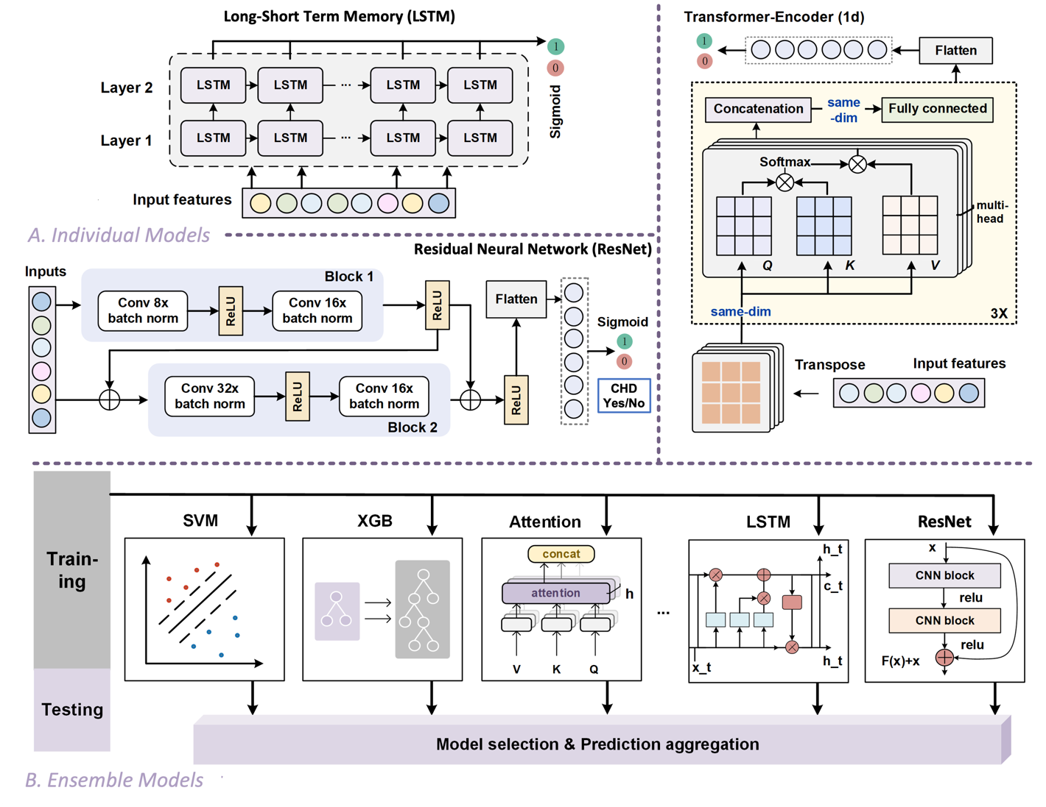

**Figure 1 A detailed schematic diagram of individual models and ensemble models.** (A) The model architecture of individual LSTM, ResNet, Transformer-Encoder methods utilized for the computational prediction of CHD. (B) The ensemble models were constructed by aggregating the predictions of selected machine learning and deep learning methods.

Here, we incorporated 6 nominal variables (e.g. male, education and so on) one-hot encoded and 8 continuous variables (e.g. age, BMI and so on) with column-based standardization, to develop a computational prediction method for 10-year risk of future CHD. Specifically, we examined 5 machine learning models, including Logistic Regression (LR), Naïve Bayes (NB), Random Forest (RF), Support Vector Machine (SVM), and eXtreme Gradient Boosting (XGB) and 4 deep learning models, including Long Short-Term Memory Neural Network (LSTM), Residual Neural Network (ResNet), Convolutional Neural Network (CNN) and 1 dimensional Transformer Encoder (Trans-Encoder). The performance of these individual models achieved an AUROC between 0.498 and 0.717. Since ensemble models usually possess multiple advantages, such as improved accuracy, reduced overfitting, and higher robustness, we conducted a comprehensive model selection process and constructed the ensembles of these individual models with different combinations. However, most ensemble models didn’t reach the best performance achieved by individual models and even the best one reached an AUROC of 0.717. **Figure 1** provides a detailed schematic diagram of 4 deep learning approaches and ensemble models. Finally, to seek for explanations of this ordinary performance, SHapley Additive exPlanations (SHAP) are applied on those models used for ensemble model construction, providing insight of most important variables for CHD risk prediction.

**2 Methods**

**2.1 Benchmark dataset**

To develop our 10-year risk of future CHD prediction framework, risk factors from 644 CHD-positive patients (dataset P) and 3594 CHD-negative patients were obtained from an ongoing cardiovascular study on residents of the town of Framingham, Massachusetts. Since there is a serious bias between positive and negative data, the negative data (dataset N) was randomly selected from CHD-negative patients with 1:1 P-to-N ratio. The dataset was randomly split into the training and testing set with a ratio of 4:1. Then the training set was further divided into training part and validation part for 5-fold cross validation.

**2.2 Risk factors**

The 15 medical records include both demographic, behavioral, and medical risk factors. For demographic risk factors, sex (stored in ‘male’) and age (stored in ‘age’) are taken into consideration. For behavioral risk factors, whether the patient is a current smoker (stored in ‘Current Smoker’) is examined and even more specific, the number of cigarettes that the person smoked on average in one day (stored in ‘cigsPerDay’) was recorded. Medical risk factors can be categorized into two conditions: history or current. For history medical risk factors, we check whether the patient was on blood pressure medication (stored in ‘BP Meds’), had previously had a stroke (stored in ‘prevalent Stroke’), the patient was hypertensive (stored in ‘prevalent Hyp’) and the patient had diabetes (stored in ‘diabetes’). For current medical risk factors, we examined the total cholesterol level (stored in ‘totChol’), systolic and diastolic blood pressure (stored in ‘sys BP’ and ‘dia BP’), body mass index (stored in ‘BMI’), heart rate (stored in ‘heartRate’), glucose level (stored in ‘glucose’) and the target for prediction which is 10-year risk of coronary heart disease CHD (stored in ‘TenYearCHD’).

**2.3 Data preprocessing**

Above 15 variables can be categorized into 6 nominal variables (e.g. male, education and so on) and 8 continuous variables (e.g. age, BMI and so on) for training and 1 nominal variables (‘TenYearCHD’) for labelling. To eliminate false ordinality in numeric categories, one-hot encoding strategy was applied to those 6 nominal variables, thus preventing the model incorrectly interpret these category labels as representing some sort of order or magnitude. To prevent an unfair feature examination, we maintain consistent data scale usingstandardization formula **(1)** towards the 14 training features across all sets. Without consistent scaling, a higher coefficient might not necessarily imply higher importance, as it could be reflecting the scale of the feature rather than its actual influence.

$$\begin{aligned}z=\frac{\left(x-μ\right)}{σ}\#(1)\end{aligned}$$

where $x$ is the original value of a feature, $μ$ is the mean of the feature, $σ$ is the standard deviation of the feature and $z$ is the standardized value.

**2.4 Individual models training**

To train induvial models for CHD prediction, we examined 5 machine learning approaches, including LR, NB, RF, SVM and XGB, alongside with 4 deep learning approaches, including LSTM, ResNet (Residual block + CNN), CNN, Trans-Encoder. These models were trained and evaluated using a benchmark dataset with a balanced positive-negative ratio of 1:1. The benchmark dataset was split into a 4:1 ratio for training and testing, respectively, with 5-fold cross-validation utilized during training. Subsequently, the top 4 performing methods in ML and top 2 performing method in DL were selected to construct ensemble models, for which the final result was obtained by aggregating the predicted values from each model. 5 different combinations of these selected methods were evaluated and compared; for each individual combination, we test it on the same testing dataset for performance evaluation.

**2.5 LSTM**

Long Short-Term Memory Network (LSTM) is a specialized variant of Recurrent Neural Network (RNN), which has been widely used in NLP tasks such as text categorization, machine translation and language models. LSTMs effectively addressed the challenge of vanishing or exploding gradients encountered by conventional RNNs when processing long series of data. In our study, the input of LSTM was set to be a 1-dimentional input vector, consisting of 24 dimensions for 16 one-hot encoded nominal variables and 8 continuous variables. The hidden size was set to be 256. We utilized two LSTM layers for model construction, followed by a linear layer to reduce the output to a single value. A sigmoid activation function was applied at the end to obtain a binary output. The LSTM model architecture is displayed in **Figure 1-A**. For training, we employed binary cross-entropy loss as the loss function and Adam optimizer with learning rate set to be 0.001. The epoch was set to be 50.

**2.6 ResNet**

ResNet is a model composed by convolutional blocks and residual structures to evaluate the risk of 10-year risk of future coronary heart disease (CHD). To be specific, both convolutional blocks were configured as 1-dimensional with a kernel size of 3, stride of 1, and padding of 1. Within the first convolutional block, the data passed through a convolutional layer, followed by a batch normalization and a ReLU activation. Subsequently, the processed data underwent another convolutional layer and a batch normalization. The number of channels of each convolutional layer is set to [8, 16]. The second block shared similar architecture as the first convolutional block. The number of channels of each convolutional layer is set to [32, 16]. Two residual blocks were implemented after two convolutional blocks, though a shortcut connection, adding the output from the previous layer to the output of the current layer. Next, the output is flattened and passed through dense layers, and fed into a sigmoid activation function for binary classification (suffer CHD within ten years Yes/No). Here is the formula **(2)** for sigmoid activation function, where z is the input in the last two neuron before activation.

$$\begin{aligned}Sigmoid\left(z\right)=\frac{1}{1+e^{-z}}\#(2)\end{aligned}$$

The loss function employed in this ResNet is binary cross entropy (i.e. BCELoss):

$$\begin{aligned}BCELoss=-\frac{1}{N}\sum_{i=1}^{N}{\left[y_{i}⋅\log{p_{i}}+\left(1-y_{i}\right)⋅\log\left(1-p_{i}\right)\right]}\#(3)\end{aligned}$$

where $N$ is the total number of samples. $y_{i}$ is the label of each individual sample, with a value of either 0 or 1. $p_{i}$ is the predicted probability that the sample belongs to class 1, as predicted by the model for each sample. $log$ denotes the natural logarithm. The loss can also be expressed as

$$\begin{aligned}BCELoss = \left\{\begin{aligned}-\log\left(\text{sigmoid}\left(z\right)\right) \text{if }y_{1}=1 \\ -\log\left(1-\text{sigmoid}\left(z\right)\right) \text{if }y_{1}=0\end{aligned}\right.\#(4)\end{aligned}$$

The Adam optimizer was implemented with a starting learning rate of 0.001, which takes advantage of the momentum strength and adaptive learning rate simultaneously. The epoch for the training was set to be 100.

**2.7 Transformer-Encoder**

Transformer is a prevalent Seq2seq model first proposed for neural machine translation and subsequently has been applied to many NLP tasks. It functioned through an Encoder-Decoder architecture. Since it has the potential to be adapted for various types of disease risk evaluation tasks, we involved it in our study. Here, we only employed the Encoder module of the Transformer model: our model is mainly comprised by three multi-head self-attention layers. In each multi-head attention layer, multiple self-attention heads are parallel attention structures operating on the input sequence. For each attention head, three linear transformations of the input embeddings are derived: Query (Q), Key (K), and Value (V). These vectors are then used to compute the attention scores as follows:

$$\begin{aligned}\text{Attention}\left(Q,K,V\right)=\text{softmax}\left(\frac{QK^{T}}{\sqrt{d_{k}}}\right)V\#(5)\end{aligned}$$

where $d_{k}$ is the column number of those equal-sized three matrixes, i.e. the matrix dimension. A softmax function is used to weight the corresponding value vectors. The concatenation of the resulting projection of this kind of attention head is then linearly transformed to finally produce the output of the multi-head attention layer. The model architecture is displayed in **Figure 1-A**.

Details of hyperparameters used in this study were set as follow. The input to this model is a vector that incorporating scaled 16 one-hot encoded nominal variables and 8 continuous variables; thus the total feature length is of 24. This is to make the input fit the model's dimensional requirement: the input 1-d vector was transformed into a 3×8 matrix. In each multi-head self-attention layer, the head number is set to be 4. The dimension of each Query, Key, and Value matrix is (8/4)×3. The number of Encoder layers is set to 3. The final output of the Encoder module is flattened and passed through a fully connected layer with an output dimension of 2 to predict whether a person will suffer CHD or not within 10 years or not in the future. The loss function employed in our Transformer Encoder is cross entropy. Stochastic Gradient Descent (SGD) is selected as the optimizer with a learning rate of 0.005 and without momentum mechanism. The epoch for training was 15.

**2.8 Ensemble Learning**

Ensemble learning is a technique that combines the power of multiple predictive models to improve overall performance. The ensemble model was selected as one of our comparison methods for three reasons including reduced overfitting, improved accuracy, and improved robustness. Ensemble model (**Figure 1-E**) considered multiple combinations of methods to give a comprehensive evaluation. Methods with high AUROC in cross validation set and independent test set were selected for constructing ensemble model. In machine learning methods, Logistic Regression (LR), Naïve Bayes (NB), Random Forest (RF), Support Vector Machine (SVM) were selected, while in deep learning methods, Long-Short Term Memory Neural Network (LSTM) and Recurrent Neural Network (ResNet) were selected. Here we considered five combinations following their AUROC: 1. LR and LSTM (top 2); 2. LR, NB and LSTM (top 2 in ML and top 1 in DL); 3. LR, NB and ResNet (top 2 in ML and rank 2 in DL); 4. LR, NB, RF and LSTM (top 4); 5. LR, NB, RF, SVM and LSTM (top 5). Those ensemble models were evaluated and compared with each other. The ensemble method aggregates predictions from these different models by taking an average of their output as a fusion result. Ideally, due to the combination of multiple models, the integrated model tends not to be overly dependent on specific features of the training data, thus reducing the risk of overfitting. Meanwhile, the integrated model is less sensitive to small changes and outliers in the data.

**2.9 Performance evaluation metrics**

The following evaluation metrics were applied. We used the Receiver Operating Characteristic (ROC) curve (sensitivity against 1-specificity) and the area under the ROC curve (AUROC). Besides AUROC, sensitivity (Sn), specificity (Sp), overall accuracy (ACC), F1 score, and Matthew's Correlation Coefficient (MCC) were also included. A 5-fold cross-validation was applied on 80% of the data as training datasets, while the rest of 20% were used as testing datasets for independent testing.

$$\begin{aligned}S_{n}=\frac{TP}{TP+FN}\#(6)\end{aligned}$$

$$\begin{aligned}S_{p}=\frac{TN}{TN+FP}\#(7)\end{aligned}$$

$$\begin{aligned}ACC=\frac{TP+TN}{TP+TN+FP+FN}\#(8)\end{aligned}$$

$$\begin{aligned}MCC=\frac{TP×TN-FP×FN}{\sqrt{\left(TP+FP\right)×\left(TP+FN\right)×\left(TN+FP\right)×\left(TN+FN\right)}}\#(9)\end{aligned}$$

$$\begin{aligned}F1=\frac{2TP}{2TP+FP+FN}\#(10)\end{aligned}$$

Among them, TP represents the number of true positives, while TN represents true negatives; FP stands for the number of false positives, and FN stands for the number of false negatives.

**2.10 SHAP analysis**

Drawing on the principles of Shapley values (Shapley, 1952) from cooperative game theory, initially introduced by Shapley et al., SHAP distributes the contributions of individual features towards the prediction of a particular instance. Given a model $f$, the Shapley value $ϕ_{j}$ for the $j$-th feature is defined as:

$$\begin{aligned}ϕ_{j}\left(x\right)=\sum_{S⊆N∖\{j\}}{\frac{\left|S\right|!\left(\left|N\right|-\left|S\right|-1\right)!}{\left|N\right|!}}\left[f_{S∪\{j\}}\left(x\right)-f_{S}\left(x\right)\right]\#\left(11\right)\end{aligned}$$

where $N$ denotes the set of all features, with $\left|N\right|$ indicating the total number of features. $\left|S\right|$ refers to the number of features in set $S$. The model's prediction $f_{S∪\{j\}}\left(x\right)$ includes the features in set $S$ along with the $j$-th feature. In contrast, $f_{S}\left(x\right)$ is the prediction considering only the features in set $S$.

The Shapley value $ϕ_{j}\left(x\right)$ quantifies the average incremental effect of the $j$-th feature when combined with all other possible feature sets. A positive SHAP value suggests that the feature contributes to an increase in the model's prediction compared to a baseline, whereas a negative SHAP value points to a reduction. The size of the SHAP value denotes the extent of the feature's influence on the prediction.

**3 Results**

**3.1 Single-model methods evaluation**

To develop our prediction method, we first evaluate the performance of different approaches for CHD risk prediction within 10 years using both machine learning and deep learning methods. Five different machine learning classifiers were included: Logistic regression (LR), Naïve Bayes (NB), Random Forest (RF), Support Vector Machine (SVM), and eXtreme Gradient Boost (XGB). Four deep learning methods were included: Convolutional Neural Network (CNN), Long-Short Term Memory (LSTM) and Residual Neural Network (ResNet) and 1 dimensional Transformer Encoder (Trans-Encoder). Performance evaluation of these methods has been summarized in **Table 1**. Additionally, we demonstrated a combined ROC figure for cross validation (**Figure 2a**) and independent test (**Figure 2b**). The results indicated that logistic regression and naïve bayes for machine learning approaches and LSTM for deep learning approaches are generally outperform other models.

**Table 1 Performance evaluation of single-model methods**

|  |  |  |  |  |  |  |  |
| --- | --- | --- | --- | --- | --- | --- | --- |
| **Methods & Modes** | | **Sn (%)** | **Sp (%)** | **ACC (%)** | **F1** | **MCC** | **AUROC** |
| **LR** | Cross Validation | 0.611 | 0.711 | 0.650 | 0.657 | 0.309 | 0.720 |
| Independent Test | 0.659 | 0.696 | 0.678 | 0.677 | 0.358 | 0.717 |
| **NB** | Cross Validation | 0.159 | 0.947 | 0.534 | 0.273 | 0.255 | 0.694 |
| Independent Test | 0.121 | 0.667 | 0.519 | 0.205 | 0.099 | 0.709 |
| **RF** | Cross Validation | 0.566 | 0.674 | 0.612 | 0.615 | 0.233 | 0.663 |
| Independent Test | 0.545 | 0.632 | 0.605 | 0.585 | 0.214 | 0.666 |
| **SVM** | Cross Validation | 0.575 | 0.625 | 0.578 | 0.599 | 0.155 | 0.653 |
| Independent Test | 0.553 | 0.664 | 0.628 | 0.603 | 0.262 | 0.658 |
| **XGB** | Cross Validation | 0.566 | 0.646 | 0.592 | 0.604 | 0.189 | 0.623 |
| Independent Test | 0.492 | 0.570 | 0.550 | 0.528 | 0.104 | 0.632 |
| **LSTM** | Cross Validation | 0.724 | 0.592 | 0.655 | 0.667 | 0.319 | 0.711 |
| Independent Test | 0.742 | 0.603 | 0.674 | 0.700 | 0.349 | 0.709 |
| **ResNet** | Cross Validation | 0.561 | 0.565 | 0.563 | 0.550 | 0.126 | 0.565 |
| Independent Test | 0.455 | 0.619 | 0.535 | 0.500 | 0.075 | 0.559 |
| **CNN** | Cross Validation | 0.959 | 0.028 | 0.471 | 0.632 | -0.036 | 0.505 |
| Independent Test | 0.962 | 0.016 | 0.500 | 0.663 | -0.067 | 0.587 |
| **Trans-Encoder** | Cross Validation | 0.468 | 0.551 | 0.512 | 0.477 | 0.019 | 0.513 |
| Independent Test | 0.606 | 0.421 | 0.516 | 0.561 | 0.027 | 0.498 |

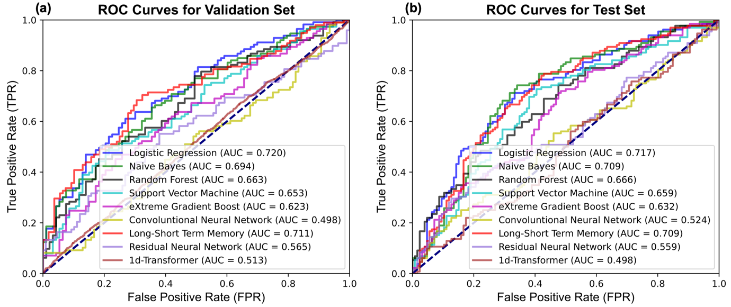

**Figure 2 The ROC curves of single-model methods. (A)** The ROC curves of multiple approaches for predicting 10-year risk of future coronary heart disease (CHD) under the 5-fold cross-validation test. **(B)** The ROC curves of multiple approaches for predicting 10-year risk of future coronary heart disease (CHD) under the independent dataset test.

**3.2 Ensemble-model methods evaluation**

From **Table 1**, we can see that LR, NB, RF and SVM are the top 4 machine learning approaches with the best performance; and LSTM and ResNet are the top 2 deep learning approaches with the best performance. Next, we constructed ensemble models by applying different combinations of models from those 6 methods. The performance evaluation toward those methods in independent test is summarized in **Table 2** and a combined ROC figure for independent test is demonstrated in **Figure 3**. The ensemble method aggregated predictions from these different models by fusing their output to make a final decision. All ensemble methods demonstrated improvement in AUROC (0.698-0.717) compared to the average AUROC of individual methods (0.498-0.717). The ensemble model of LR and LSTM combination outperformed other combinations with an AUROC value of 0.717.

**Table 2 Performance evaluation of ensemble-model methods**

|  |  |  |  |  |  |  |
| --- | --- | --- | --- | --- | --- | --- |
| **Ensemble Methods** | **Sn (%)** | **Sp (%)** | **ACC (%)** | **F1** | **MCC** | **AUROC** |
| LR + LSTM | 0.689 | 0.675 | 0.682 | 0.689 | 0.363 | 0.718 |
| LR + NB + LSTM | 0.189 | 0.913 | 0.543 | 0.297 | 0.147 | 0.715 |
| LR + NB + ResNet | 0.136 | 0.929 | 0.523 | 0.226 | 0.106 | 0.697 |
| LR + NB + RF + LSTM | 0.287 | 0.897 | 0.585 | 0.415 | 0.232 | 0.704 |
| LR + NB + RF + SVM + LSTM | 0.364 | 0.849 | 0.601 | 0.482 | 0.243 | 0.700 |



**Figure 3 The ROC curves of ensemble-model methods.** The figure shows ROC curves of ensemble models with 5 different method combinations of top 6 performing individual models under the independent dataset test.

**3.3 Model interpretation**

During the process of individual model examination, 4 machine learning models (LR, NB, RF, and SVM) and 2 deep learning models (LSTM and ResNet) outcompete other models, thus selected for following ensemble model construction. Therefore, we will specifically focus on explaining these models with two aims: 1. Identify common significant variables shared 6 models for CHD risk prediction. 2. Check the SHAP value distribution across 6 models to give insight for explaining the relatively ordinary performance (lower than 0.7) of RF, SVM and ResNet.

SHAP interpretation of these models are demonstrated in **Figure 4**. From this figure, age (stored in ‘age’), systolic blood pressure (stored in ‘sysBP’), and the number of cigarettes that the person smoked on average in one day (stored in ‘cigsPerDay’) are shown to be three most frequently occurred variables when explaining models, thus indicating the significance of these variables in CHD risk prediction. These three significant variables coincide with our expectations: 1. For age, CHD is related to gradual buildup of plaques in the coronary arteries, increased arterial stiffness, and a general decline in heart function. 2. For systolic blood pressure, it exerts extra force against the artery walls, accelerating the wear and tear that may contribute to the formation of plaques. 3. For averaged cigarettes intake per day, smoking cigarettes introduces numerous harmful chemicals into the body, many of which can damage the cardiovascular system, thus enhancing the risk of CHD.

To providing potential explanations for their relatively ordinary performance, we compared the SHAP analysis results of RF, SVM and ResNet with other models. From the SHAP visualizations, we found that many features contribute significant positive or negative values across different samples, suggesting that these three models might be overfitting to the noise or highly correlated features in the dataset.



*(Legends on the next page)*

**Figure 4 Model interpretation with SHAP analysis**. The significance of each risk factor for the CHD risk prediction was assessed across 4 top performing ML models (a1-a4) and 2 top performing DL models (b1-b2). For each model, SHAP values for each variable were retrieved from different samples; variables were ranked and demonstrated according to the mean of absolute SHAP values (left) with their distribution of SHAP values (right).

**4 Discussion**

**4.1 Deep learning models reflection**

In this study, the best performing DL method (LSTM) only shows slightly higher performance (0.718) compared with the best performing ML method (LR) (0.717); other complex neural networks, such as ResNet, CNN and Trans-Encoder (0.498-0.587) performed worser than conventional ML methods (0.632-0.717), indicating that complex neural networks didn’t exhibit its own unique advantage in CHD risk prediction. This might be due to the insufficient complexity of CHD risk factors that do not require deep learning architectures to capture effectively, or possibly due to overfitting in smaller or noisier datasets. Further study should involve exploring different network architectures, implementing more robust regularization techniques, and enhancing the dataset either by expansion or through more advanced feature engineering.

**4.2 Ensemble model reflection**

To improve the model performance achieved by single-model based approach and fully leverage advantages provided by ensemble approach, we construct ensemble models with 5 different combinations among top 6 best performing single-model based approaches. However, the result of these ensemble models didn’t exhibit significant improvement with best AUROC around 0.718. Future research should consider more possible combinations for examination. Moreover, our ensemble strategy here is to aggregates predictions from these different models by taking an average of their output as a fusion result under the same testing set. However, more studies indicate ensemble different models during the training process will yield better result, thus should be considered for future study.

**4.3 Model Interpretation reflection**

From SHAP analysis results, different models show different preference towards 14 variables. We found that many features contribute significant positive or negative values across different samples, suggesting that the RF, SVM and ResNet model might be overfitting to the noise or highly correlated features in the dataset. Future investigation towards the dataset is needed for enhancing true biological related signal.

**5 Conclusion**

In this study, we firstly examine 5 machine learning models, including LR, NB, RF, SVM, and XGB and 4 deep learning models, including LSTM, ResNet, CNN and Trans-Encoder. Trained with 6 nominal variables (e.g. male, education and so on) one-hot encoded and 8 continuous variables (e.g. age, BMI and so on) with column-based standardization, the performance of these individual models achieved an AUROC between 0.498 and 0.717. Since ensemble models usually possess multiple advantages, such as improved accuracy, reduced overfitting, and higher robustness, we conducted a comprehensive model selection process and constructed the ensembles of these individual models with different combinations. However, most ensemble models didn’t reach the best performance achieved by individual models and even the best one reached an AUROC of 0.718. Finally, to seek for explanations of this ordinary performance, SHAP are applied on those models used for ensemble model construction, providing insight of most important variables for CHD risk prediction.

**6 Code availability**

The deep learning-based approaches, including CNN, LSTM, ResNet, 1 dimensional Transformer-Encoder and all ensemble models, were implemented with Pytorch 2.1.0. Codes for model construction can be available at: <https://github.com/Jiaming21/CHD_codes.git>.

**7 References**